**Tur off notifications for calendar events in Zoom**

(so that you don’t get them from both Zoom and Outlook if you connect your Outlook calendar to Zoom)

1. Open the Zoom client on your computer and go to the cogwheel

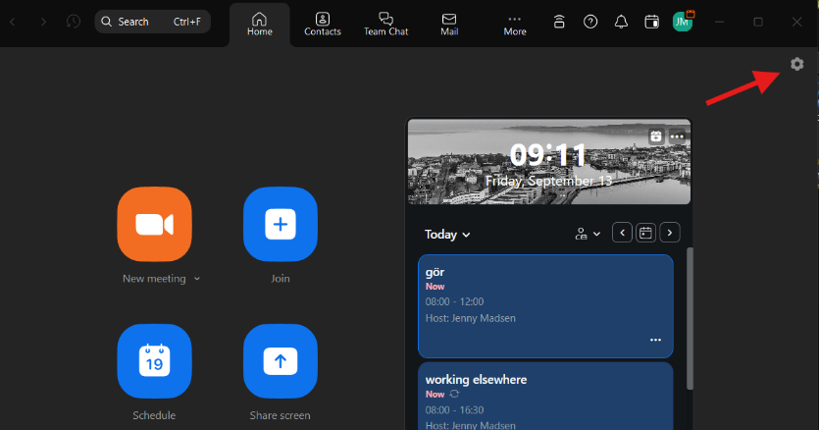

1. Make sure that you are in the menu option General and uncheck the check box by ”Remind me about upcoming events”

